-- представление вывода по расположению имени и модели устройства

**USE** inventory;

**CREATE** **OR** **REPLACE** **VIEW** view_loc_model (location, name, model)

**AS** **SELECT** location.location_name, deviсes.device_name , device_model.name

**FROM** deviсes **JOIN** device_model

**ON** deviсes.device_model_id = device_model.id

**JOIN** location

**ON** deviсes.location_id = location.id

**ORDER** **BY** location.location_name;

**SELECT** * **FROM** view_loc_model;

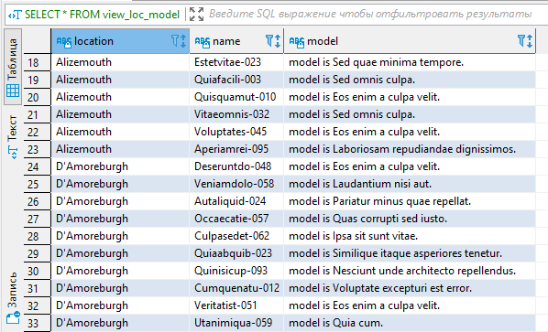

-- представление по каналам связи: провайдер, имя, статус, откуда и куда идет

**CREATE** **OR** **REPLACE** **VIEW** view_providers_summ_info (provider, channel, status, from_location, to_location)

**AS** **SELECT** providers.name, channels.name, status.name,

(**SELECT** location_name **FROM** location **WHERE** location.id = channels.from_location_id) **AS** from_location,

(**SELECT** location_name **FROM** location **WHERE** location.id = channels.to_location_id) **AS** to_location

**FROM** providers **JOIN** channels

**ON** channels.provider_id = providers.id

**JOIN** status

**ON** channels.status_id = status.id

**JOIN** location

**GROUP** **BY** channels.name

**ORDER** **BY** channels.name;

**SELECT** * **FROM** view_providers_summ_info;

